Temple Beth Zion-Beth Israel
High Holy Days 2021 - 5782
Guide to Services
Contents
High Holy Days Services Schedule 2
In Advance of the Holidays 4
Attend BZBI Weekday and Shabbat Services 4
Order High Holy Days Tickets 5
Reserve Babysitting and Youth & Family Activities 6
Complete Other Preparations 6
Making the Most of Your Zoom or Facebook Live Experience 7

High Holy Days Services Schedule

PREPARATION FOR THE HOLY DAYS
- In-Person Ticket Orders due before 5:00 PM on Friday, August 20
- Childcare and Youth & Family Reservations, due before 8:00 PM on Monday, August 23
- Lulav and Etrog orders due before 5:00 PM on Friday, August 27
- Register for Zoom High Holy Days Services at any time

Erev Rosh Hashanah, Monday, September 6, 2021 / Elul 29, 5781
- 5:00 PM: RH²: Rosh Hashanah in Rittenhouse Square
  - Josh Madoff - Keyboards, co-director
  - Dan Blacksberg - Trombone, co-director
  - Michael Winograd - Clarinet
  - Warren Mobley - Bass
  - Matt Scarano – Drums
  - Sarah Gordon, Eitan Kantor and Rebekka Goldsmith – Vocals
- 7:06 PM: Light Holiday Candles
Rosh Hashanah Day 1, Tuesday, September 7, 2021 / Tishrei 1, 5782
- 8:30 AM: Shacharit Service Begins – Multi-Access: Goldberg Sanctuary, Zoom and Facebook Live
- 9:00 AM: Service for Families with Young Children
- 9:30 AM: Childcare Begins
- 10:00 AM: Youth Programming Begins
- 10:00 AM: Teen Programming Begins
- 1:00 PM (Approx.): Multi-Access Service Ends
- 5:00 PM: Community Tashlich on the Schuylkill River at Locust Street, co-sponsored by BZBI, Mekor Habracha, and Leyv Ha-Ir
- 5:30 PM: Full Shofar Blowing at the conclusion of Taschlich.
- 8:03 PM: Light Holiday Candles from a pre-existing flame
Rosh Hashanah Day 2, Wednesday, September 8, 2021 / Tishrei 2, 5782
- 9:00 AM: Shacharit Service Begins – Multi-Access: Goldberg Sanctuary, Zoom and Facebook Live
- 9:00 AM: Childcare Begins
- 10:00 AM: Youth Programming Begins
- 10:00 AM: Shabbhakti: High Holy Day yoga with Dr. Deb Glassman - Kahaner Auditorium
- 11:00 AM: Teen Programming Begins
- 11:30 AM: Chai Chi: High Holy Day movement with Doug Barg - Kahaner Auditorium
- 1:00 PM (Approx.): Multi-Access Service Ends
- 8:01 PM: Holiday Ends

Shabbat Shuva, Saturday, September 10, 2021 / Tishrei 4, 5782
- 9:30 AM: Shabbat Service Begins – Multi-Access: Goldberg Sanctuary, Zoom and Facebook Live
- 7:56 PM: Havdallah

KOL NIDRE (EREV YOM KIPPUR), WEDNESDAY, SEPTEMBER 15, 2021 / TISHREI 9, 5782
- 6:00 PM: Childcare Begins
- 6:30 PM: Kol Nidre Service Begins – Multi-Access: Goldberg Sanctuary, Zoom and Facebook Live
- 6:51 PM: Light Holiday Candles

YOM KIPPUR, THURSDAY, SEPTEMBER 16, 2021 / TISHREI 10, 5782
- 9:00 AM: Morning Service Begins – Multi-Access: Goldberg Sanctuary, Zoom and Facebook Live
- 9:00 AM: Childcare Begins
- 9:00 AM: Service for Families with Young Children
- 10:00 AM: Youth Programming Begins
- 11:00 AM: Teen Programming Begins
- 12:00 Noon (Approx.) Yizkor Service – Multi-Access: Goldberg Sanctuary, Zoom and Facebook Live
- 12:30 PM (Approx.): Mussaf Service – Multi-Access: Goldberg Sanctuary, Zoom and Facebook Live
- 2:30 PM: Walking Meditation with Rabbi Abe – Rittenhouse Square (If raining: Kahaner Aud.)
- 3:30 PM: Shabbhakti: High Holy Day yoga with Dr. Deb Glassman - Kahaner Auditorium
- 5:00 PM: Childcare Resumes
- 5:00 PM: Mincha Service – Multi-Access: Goldberg Sanctuary, Zoom and Facebook Live
- 6:30 PM: Neilah Service – Multi-Access: Goldberg Sanctuary, Zoom and Facebook Live
- 7:30 PM: Ma'ariv Service – Multi-Access: Goldberg Sanctuary, Zoom and Facebook Live
- 7:48 PM: Break-the-fast

In Advance of the Holidays

Attend BZBI Weekday and Shabbat Services
You do not need to register in advance to attend BZBI’s multi-access religious services in-person. This includes Kabbalat Shabbat in Fitler Park at 6:00 PM on Fridays (or the Klinghoffer Chapel if inclement weather is forecast) and Shabbat service in the Goldberg Sanctuary on Saturdays at 9:30 AM).
However, we ask that once inside our building, you observe BZBI’s rules, which were put in place with the guidance of our COVID task force, the city of Philadelphia, and State of Pennsylvania:
- Wear a mask while in the building
- Maintain social distancing
- Wash your hands and use hand sanitizer frequently
- Use the bathroom designated for you, and use a sanitizing wipe on surfaces afterward.
We also ask that you pledge for yourself and those with whom you may be attending that you will not attend any service or program at BZBI if you or those attending with you experience any of the potential indicators listed below, or are awaiting the results of a COVID-19 test:
- Continuous or intermittent cough
- Shortness of breath
- Fever or feel feverish (with or without chills)
- Sore throat
- Headache, muscle aches or muscle pain
- Recent loss of the sense of taste or smell
- Fatigue (tired)
- Congestion or a runny nose
- Recent nausea, vomiting or diarrhea
- Recent infection requiring prescription medication
- Exposure in the last 14 days to someone with a cold, flu contagious illness, or suspicion of COVID-19.
You are always welcome to join our services on Zoom, including Kabbalat Shabbat, Saturday Morning, Sunday minyan (9:00 AM). daily morning minyan (Mon-Fri, 7:45 AM) and daily evening minyan (Mon-Thurs, 8:30 PM). Register for these services here.
D’vrei Torah from the Rosh Hashanah and Yom Kippur Services may be viewed after the Yom Tov and throughout the year on our Virtual BZBI webpage. We will also have recording of the full services available at the site.

Order High Holy Days Tickets

BZBI will offer multi-access services for adults during the High Holy Days, including in-person, Zoom and Facebook Live. We will provide a meaningful and fulfilling High Holy Day experience for all of our members, regardless of how you access the services. Reserve your tickets here before the close of business on Friday, August 20, 2021.

We are all aware that the current public health situation is fluid and could change at any time. At present, we have enough seating in the Sanctuary to accommodate all BZBI members who want to attend in person.
Senior Rabbi Abe Friedman and Assistant Rabbi Abi Weber will lead our services, with Eitan Kantor and Rebekka Goldsmith as ba’alei tefillah (prayer leaders).
Please note the following health and safety guidelines for this year’s High Holy Days:
- All in-person participants aged 12 and older must be fully vaccinated no later than Monday, August 23.
- Everyone aged 2 and older entering BZBI must wear a mask covering nose and mouth, with limited exceptions for Torah readers, prayer leaders, and other roles specifically designated by our rabbis.
- Our medical advisors have determined that social distancing will not be necessary given the other precautions we have put in place.
Review the current High Holy Days health and safety guidelines on our website by clicking here. If you are unvaccinated, immunocompromised, or do not feel you can fully abide by these guidelines, we ask that you participate using Zoom or Facebook Live.
Guest Attendance: We can’t guarantee the availability of guest tickets until we have verified space in the Sanctuary for our active members, but the member registration form allows you to place your guests’ names on a waiting list, should additional tickets be available. There will be no late opportunities for members to request tickets! Guest tickets for Sanctuary services are $180 per person.
Zoom Services will be live streamed from the Goldberg Sanctuary using the same functionality as last year, including Zoom Kiddush. There is no charge for guests who join on Zoom, although we always appreciate a donation in keeping with the season. All members and guests are invited to register for Zoom services here.
Facebook Live Services will be offered concurrent with Zoom services at no charge for our wider community. You do not need to be a member of BZBI to attend. Simply go to the BZBI Facebook page and click on the live video link any time during the service.
Multi-Access Services: BZBI Members are free to mix and match from among these three means of attending services, in the manner that best meets your needs.

Reserve Babysitting and Youth & Family Activities
Childcare will be available at BZBI during morning services on the first & second days or Rosh Hashanah, Kol Nidre, and morning and afternoon/evening services on Yom Kippur. Childcare and Youth and Family services will utilize additional spaces in our building.
Space must be reserved in advance. To maintain social distancing among young children not eligible for vaccination, we are utilizing Kahaner Auditorium and other rooms throughout the building. The form for reserving your child (or children's) spots is located here.

Complete Other Preparations

- Order Your Lulav and Etrog Sets
The holiday of Sukkot begins on Monday evening, September 20, and BZBI is taking orders for personal Lulav and Etrog sets. The cost is the same as last year at $54 per set, and the deadline to place orders is Friday, August 27th. Please note that once the deadline passes, we cannot place additional orders. Click here to order your set.

- Gather Items for the Clothing Drive
The Tikkun Olam committee seeks warm socks, undershirts, hand sanitizers, and used Cool Keppies for Kids baseball caps for local shelters and those in need. Please bring these items to the drop box in the Temple office. For more information, contact Rosalie Kurz.

- Visit the BZBI Sisterhood gift shop
You will find apple and honey dishes, shofars, kiddush cups, candles & candlesticks, books and gifts for children, and more at the gift shop! Proceeds from the gift shop benefit the Laurie Wagman Playschool, Abigail R. Cohen Preschool, and Neziner Hebrew School. Visits are by appointment only. Please email the Temple office or call 215-735-5148.

- Pick up your Book of Remembrance
The Book of Remembrance, used during Yizkor services four times a year, is only available as a printed booklet. If you attend services in-person, personal copies of the Book of Remembrance will be distributed near the Goldberg Sanctuary entrance. If you will be joining us over Zoom, you can pick up a copy from the synagogue office during office hours, 7:30 AM to 5:00 PM Monday – Thursday, and 7:30 AM – 1:00 PM on Friday.

- Pick up your Machzor for Use at Home
The ticket order form for in-person services includes a section that allows you to reserve a Machzor at no charge, with a refundable $90 deposit. If you wish to use a BZBI Machzor, please complete that section of the form and we will contact you with information on when you can pick up your prayer book.

Making the Most of Your Zoom or Facebook Live Experience
Said one BZBI member of last year’s live streamed service: “the staff, clergy and volunteers appear to have pulled off the unthinkable in turning an awful and terrible situation into an inclusive, participative and real solution staying as true to Jewish law and customs as possible.”
BZBI members and their guests can register for a Zoom meeting ID, which can be used to enter all High Holiday religious services from a single location.
All services can be accessed from the single Zoom meeting ID. However, only one device at a time can be used to login using that ID. You can obtain additional logins for family members and guests not in your home by registering for additional meeting IDs using alternate email addresses.
Note that special events such as Shabbhakti, Chai Chi and Youth & Family events will not be live streamed and must be attended in person.
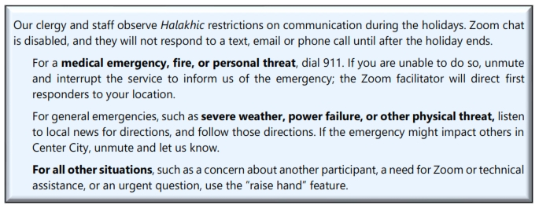
Access Services on Facebook Live
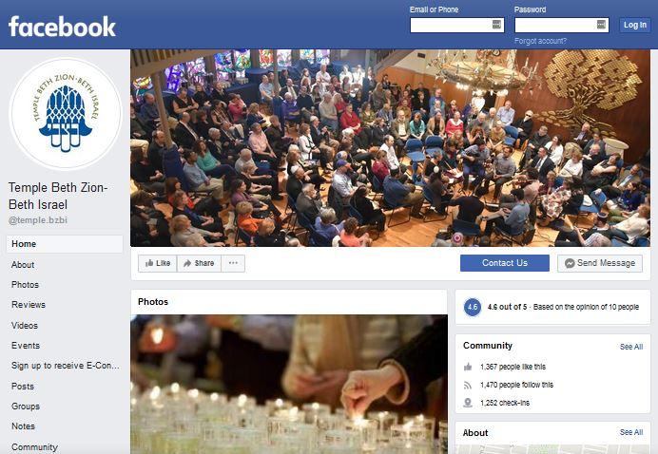
Those who are part of our wider community in Center City, Philadelphia, and around the globe are warmly invited to join our services on Facebook Live at no charge. BZBI has always offered aspects of the High Holy Days to the public, such as RH².
Anyone who wants to experience the joy of the BZBI holiday experience can have access via Facebook Live. You do not need to be a Facebook user to have access to these services.

What is the Difference Between Zoom and Facebook Live?
On Zoom, BZBI members and their guests will be able to unmute at various times to sing, talk and participate as a member of our kehillah – especially during virtual Kiddush after the Rosh Hashanah services. So, the primary difference between Zoom service for members and our free community Facebook Live is interactivity.
Become a member of BZBI, and you will also be able to soak in a full year’s worth of the richness of our community, diversity, spiritual growth, and educational opportunities.
וְעָשׂוּ לִי מִקְדָּשׁ וְשָׁכַנְתִּי בְּתוֹכָם
They will make me a sanctuary and I will dwell among them.

Setting Intention
Sitting in your living room, surrounded by relatives, guests and familiar possessions–the message of Unetaneh Tokef about the fragility of life and our tenuous mortality may take on a whole new meaning. This is a unique opportunity to understand and appreciate the liturgy and message of Rosh Hashanah and Yom Kippur differently than you ever have.
We encourage you to treat your home as an extension of the Sanctuary and suggest that you create a temporary sacred space as you prepare to enter the High Holy Days via Zoom or Facebook Live.
- Set up an area exclusively for joining in communal prayer or contemplation. Add some readings or books about Rosh Hashanah or Yom Kippur, hang a favorite picture behind you, or enhance your space with some flowers.
- If possible, set your monitor or TV so that you face east, towards Jerusalem, when you participate in services. Otherwise, at least know where it is!
- We encourage you to wear something white, and dress with the same level of respect you’d use when entering the Sanctuary.
- Just as we ask you not to eat in the Sanctuary, we ask that if you must eat during one of the services—especially Yom Kippur—that you do so offscreen, or turn off the video in the Zoom service.
Maintaining Security
- BZBI records all adult events and often makes them available for viewing by members and non-members. By participating in our events, you consent to having your image recorded. Events involving children may be recorded but are not shared except with permission of parent or guardian.
- We recommend that you keep the Zoom app on your device up to date, as new features and security enhancements are regularly added. Contact us for instructions if you need help.
- In discussion sessions, be polite and courteous. Respect the opinions and practices of others. Refrain from personal attacks. While questions and opposing opinions are encouraged, you are not to argue or openly debate.
- If you see something, say something (raise your hand) so the host can remove distractions or address a disruptive guest quickly.
- Participants will be immediately removed from a service or meeting and not allowed to return if they use rude or abusive language, make blatantly insensitive remarks, display offensive, antisemitic, racist or sexist images, solicit commercial services from other organizations, or conduct themselves in a manner that the meeting facilitator considers inappropriate.

